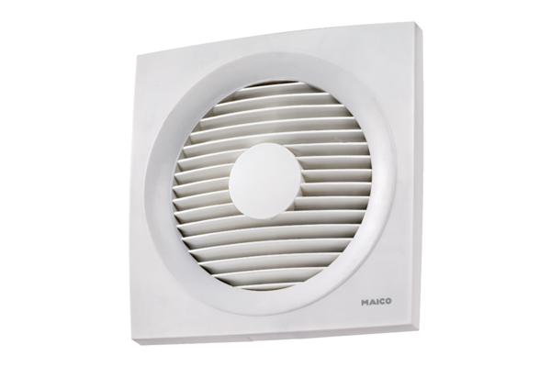Axial wall-mounted fan ENR 20Packing unit: 1 pieceRange: C
Article number: 0081.0316Manufacturer: MAICO

