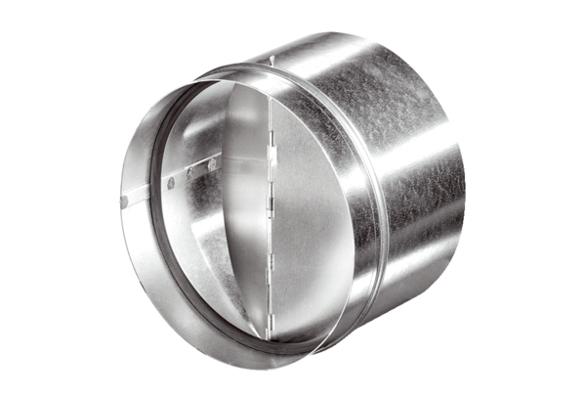Automatic backflow preventer AVM 16Packing unit: 1 pieceRange: C
Article number: 0093.0008Manufacturer: MAICO

