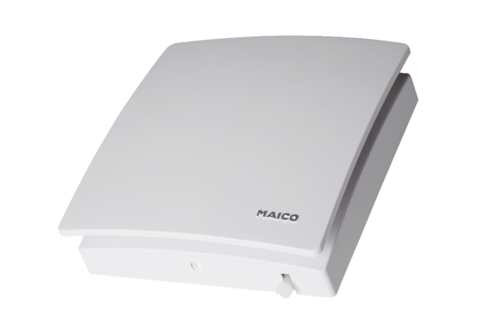Exhaust and supply air valve AZV 100Packing unit: 1 pieceRange: K
Article number: 0152.0087Manufacturer: MAICO

