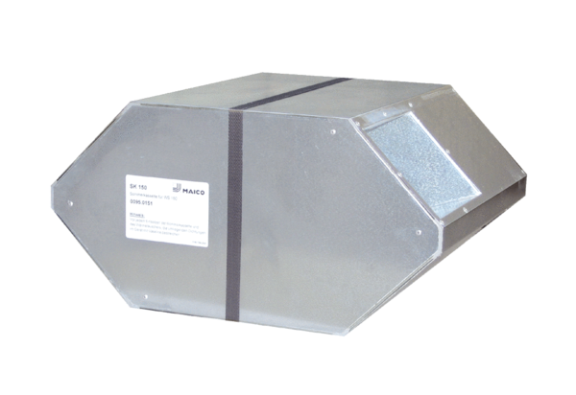Summer cassette SK 150Packing unit: 1 pieceRange: K
Article number: 0095.0151Manufacturer: MAICO

