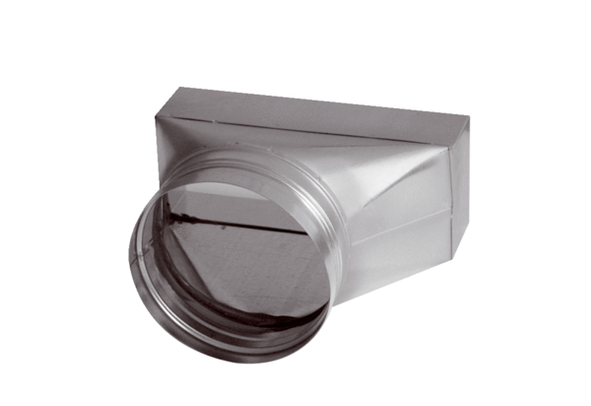Intermediate piece, asymmetric USAN55/110/80Packing unit: 1 pieceRange: K
Article number: 0055.0657Manufacturer: MAICO

