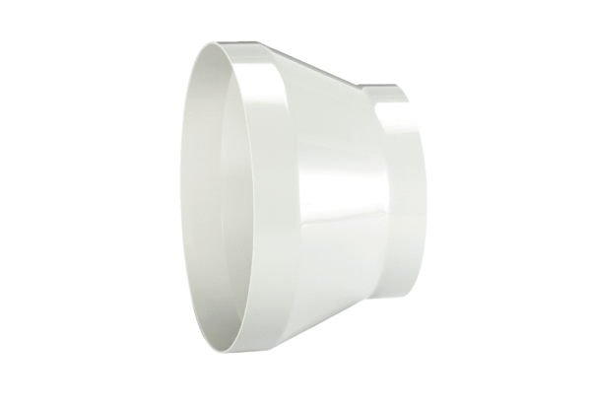Reducer REM 18/10Packing unit: 1 pieceRange: C
Article number: 0059.0627Manufacturer: MAICO

