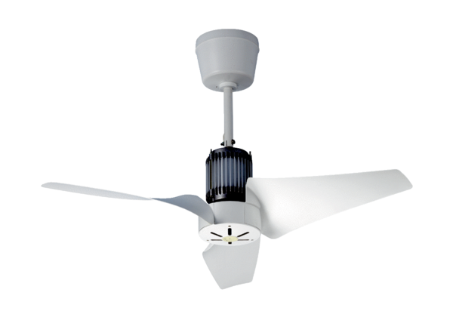EC 90 BPacking unit: 1 pieceRange: C
Article number: 0088.0121Manufacturer: MAICO

