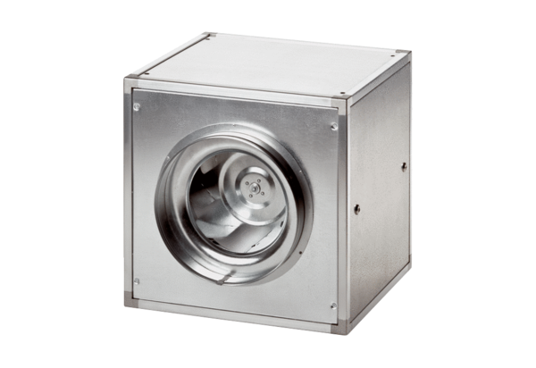Quickbox DSQ 56/6Packing unit: 1 pieceRange: C
Article number: 0080.0040Manufacturer: MAICO

