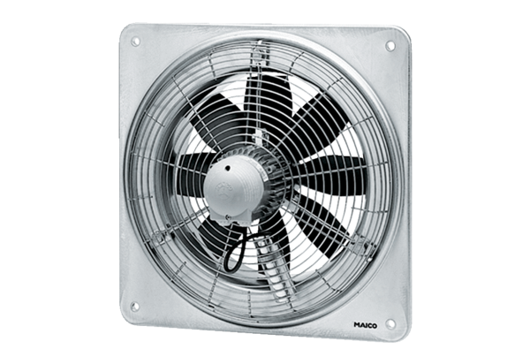Axial wall fan DZQ 60/8 BPacking unit: 1 pieceRange: C
Article number: 0083.0064Manufacturer: MAICO

