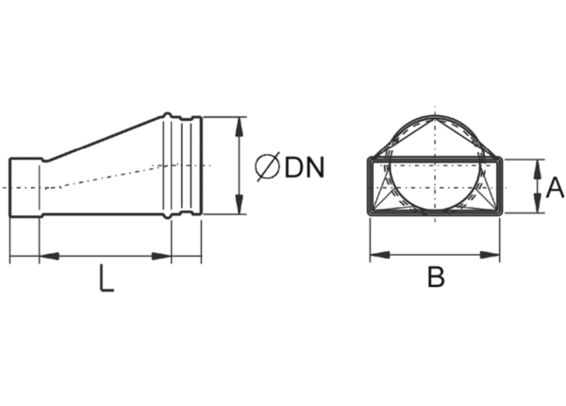Intermediate piece, asymmetric USAN55/110/100Packing unit: 1 pieceRange: K
Article number: 0055.0658Manufacturer: MAICO

