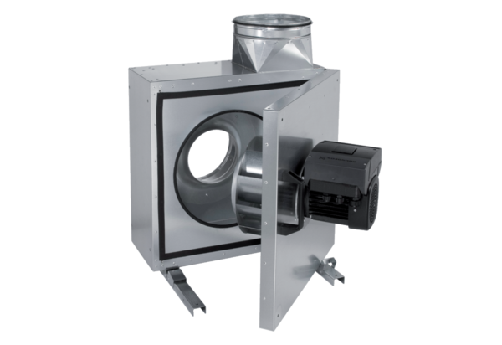Sound-insulated ventilation box EKR 25 FUPacking unit: 1 pieceRange: E
Article number: 0080.0895Manufacturer: MAICO

