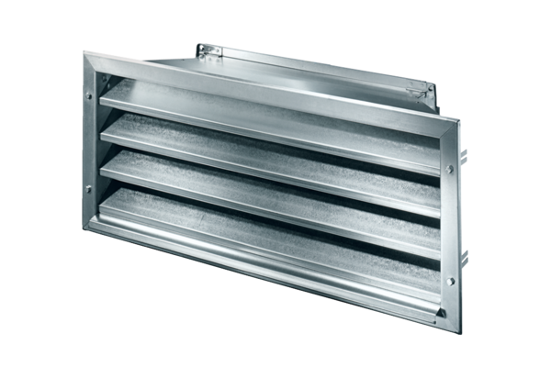External grille LZP-R 50Packing unit: 1 pieceRange: D
Article number: 0151.0386Manufacturer: MAICO

