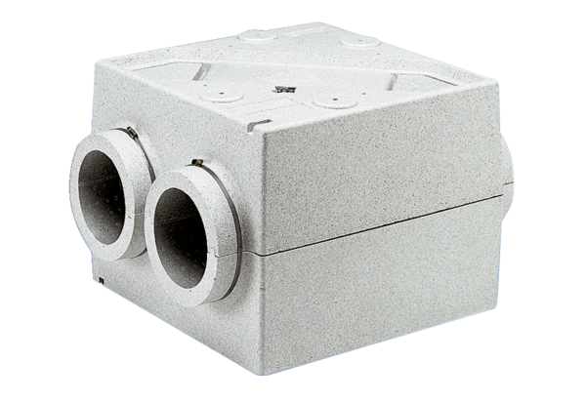Heat exchanger WT 300Packing unit: 1 pieceRange: D
Article number: 0152.0020Manufacturer: MAICO

