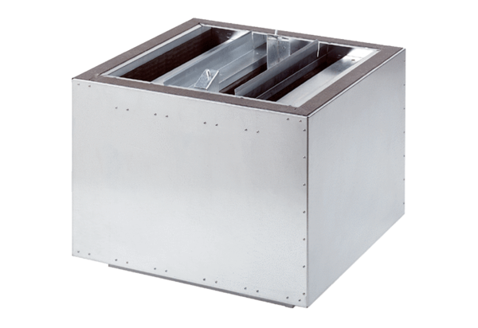Exhaust air silencer SDA 40Packing unit: 1 pieceRange: C
Article number: 0092.0390Manufacturer: MAICO

