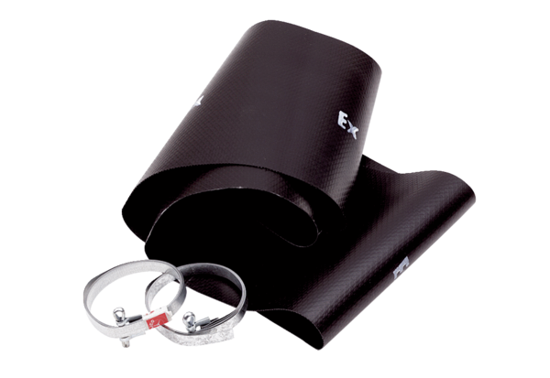Flexible cuff EL 20 ExPacking unit: 1 pieceRange: C
Article number: 0092.0231Manufacturer: MAICO

