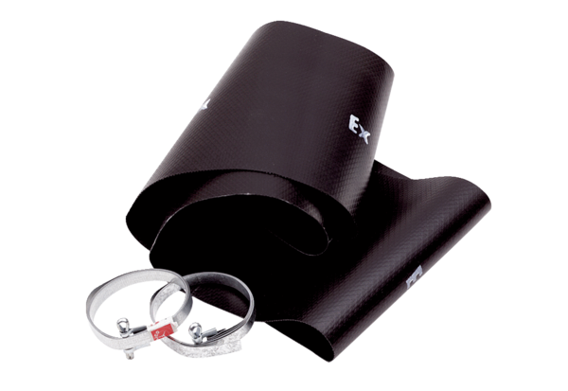Flexible cuff EL 50 ExPacking unit: 1 pieceRange: C
Article number: 0092.0237Manufacturer: MAICO

