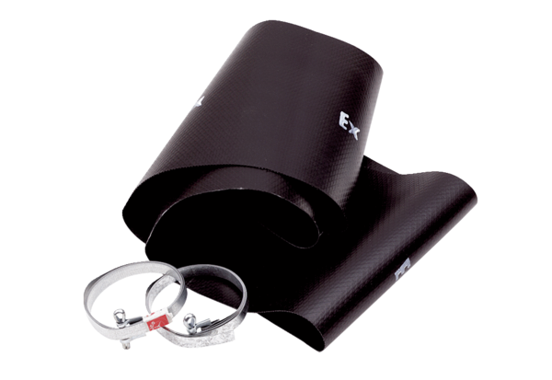Flexible cuff EL 35 ExPacking unit: 1 pieceRange: C
Article number: 0092.0234Manufacturer: MAICO

