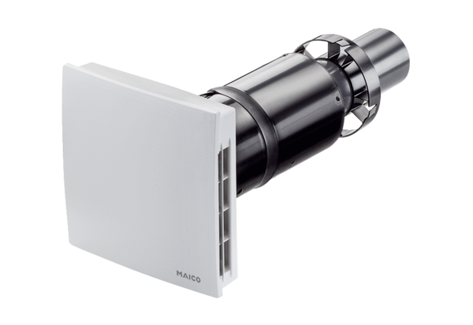Final assembly kit PPB 30 OPacking unit: 1 pieceRange: K
Article number: 0095.0245Manufacturer: MAICO

