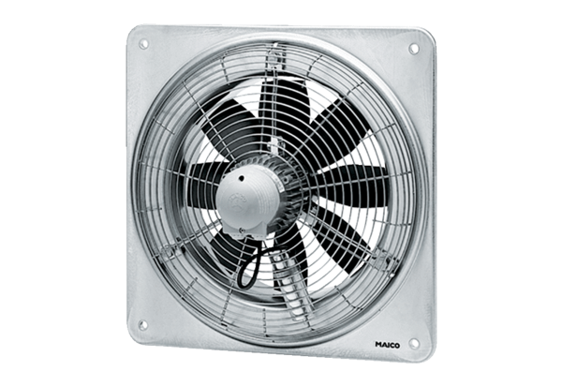Axial wall fan DZQ 40/64 BPacking unit: 1 pieceRange: C
Article number: 0083.0156Manufacturer: MAICO

