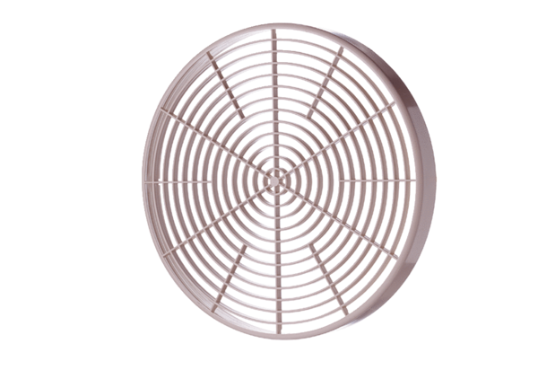SGM 22Packing unit: 1 pieceRange: C
Article number: 0059.0428Manufacturer: MAICO

