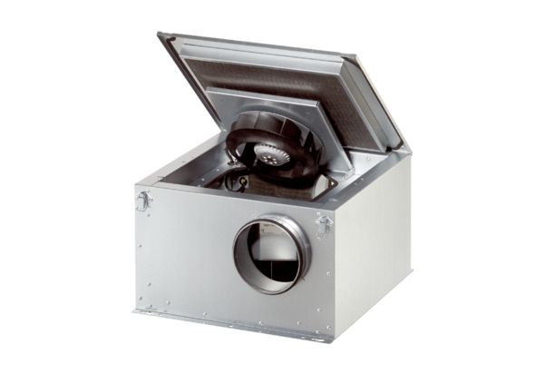Sound-insulated ventilation box ESR 12-2 ECPacking unit: 1 pieceRange: E
Article number: 0080.0710Manufacturer: MAICO

