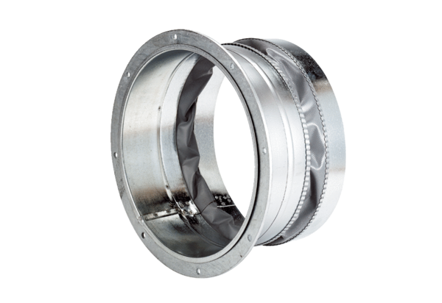Flexible coupling ELA 56Packing unit: 1 pieceRange: C
Article number: 0092.0272Manufacturer: MAICO

