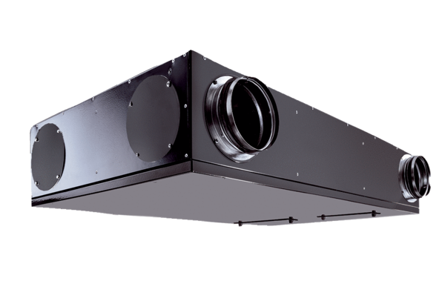Centralised ventilation unit Trio QZ-ARPacking unit: 1 pieceRange: K
Article number: 0095.0128Manufacturer: MAICO

