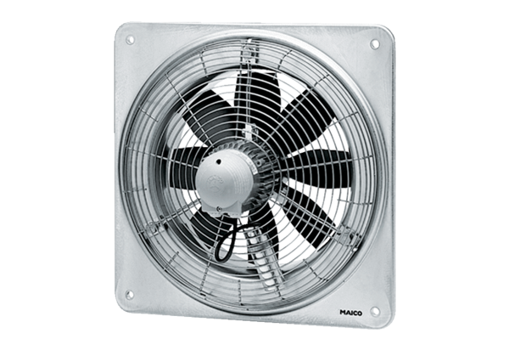Axial wall fan DZQ 35/84 BPacking unit: 1 pieceRange: C
Article number: 0083.0150Manufacturer: MAICO

