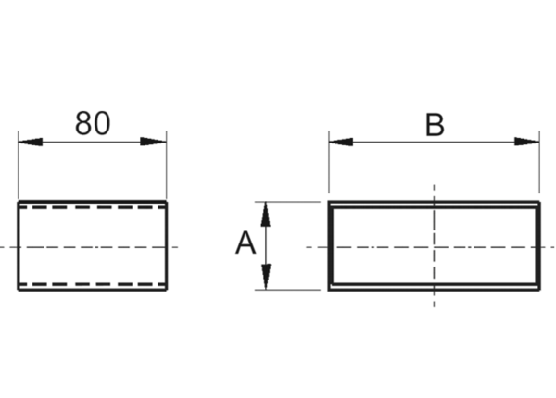Adaptor plug connector SVF55/220Packing unit: 1 pieceRange: K
Article number: 0055.0565Manufacturer: MAICO

