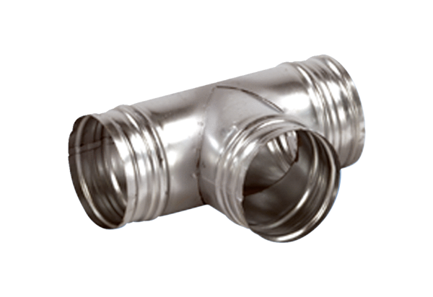90° branch AB 100-80Packing unit: 1 pieceRange: K
Article number: 0055.0348Manufacturer: MAICO

