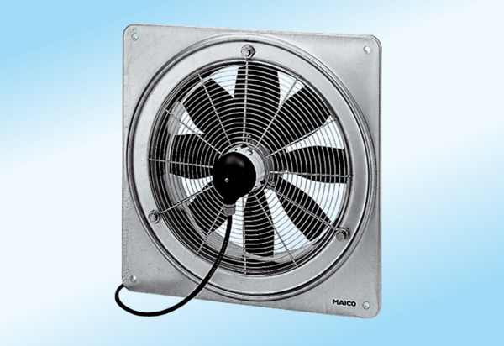Axial wall fan DZQ 25/2 A-ExPacking unit: 1 pieceRange: C
Article number: 0083.0761Manufacturer: MAICO

