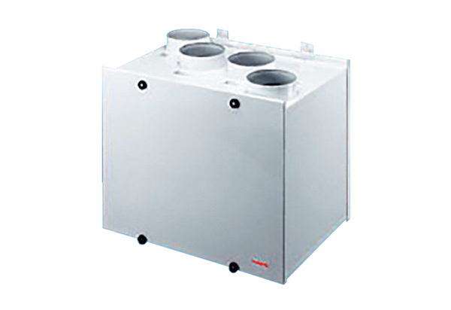Aeronom room air system WRG300WPacking unit: 1 pieceRange:
Article number: 0082.0038Manufacturer: MAICO

