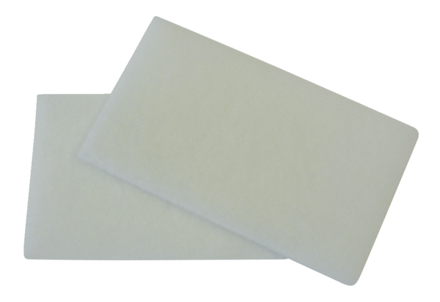Air filter, replacement WRF 300-400 ECPacking unit: 2 piecesRange: K
Article number: 0093.0061Manufacturer: MAICO

