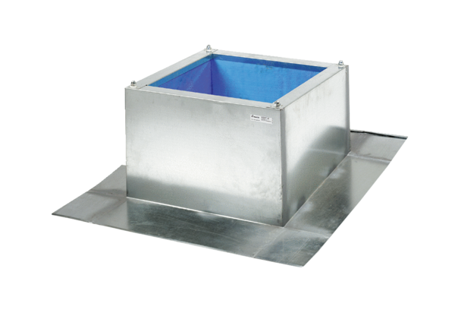Roof socket for corrugated and trapezoidal roofs SOWT 45Packing unit: 1 pieceRange: C
Article number: 0093.0989Manufacturer: MAICO

