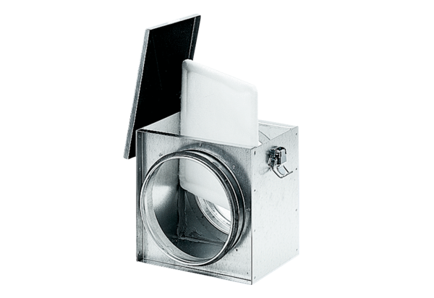Air filter TFE 12-4Packing unit: 1 pieceRange: C
Article number: 0149.0075Manufacturer: MAICO

