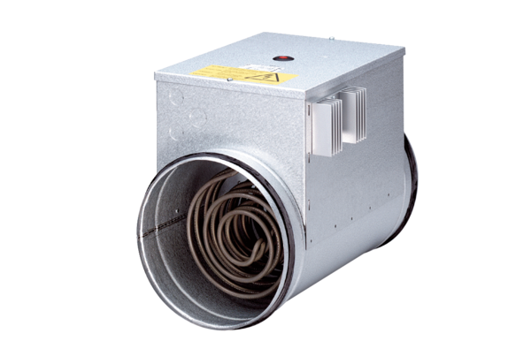Electrical air heater with controller DRH 20-6 RPacking unit: 1 pieceRange: C
Article number: 0082.0144Manufacturer: MAICO

