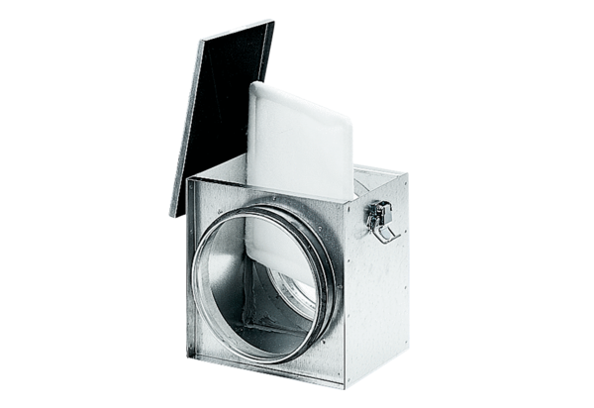Air filter TFE 31-4Packing unit: 1 pieceRange: C
Article number: 0149.0080Manufacturer: MAICO

