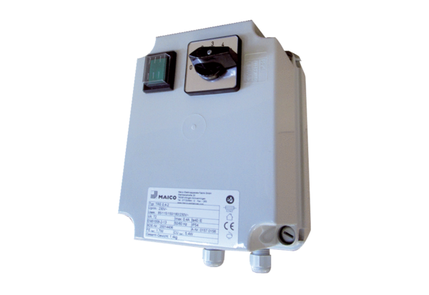5-step transformer TRE 0,6-2Packing unit: 1 pieceRange: C
Article number: 0157.0157Manufacturer: MAICO

