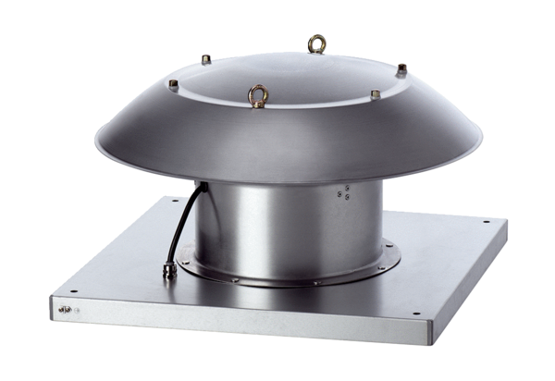Axial roof fan DZD 50/4 B Ex ePacking unit: 1 pieceRange: C
Article number: 0087.0807Manufacturer: MAICO

