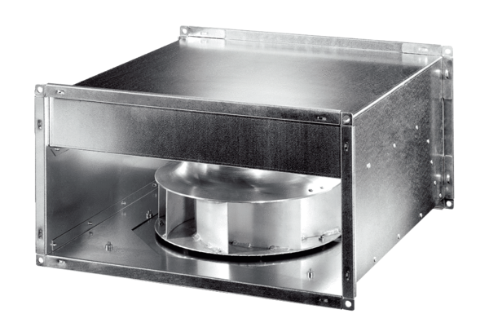Channel fan DPK 22 ECPacking unit: 1 pieceRange: E
Article number: 0086.0800Manufacturer: MAICO

