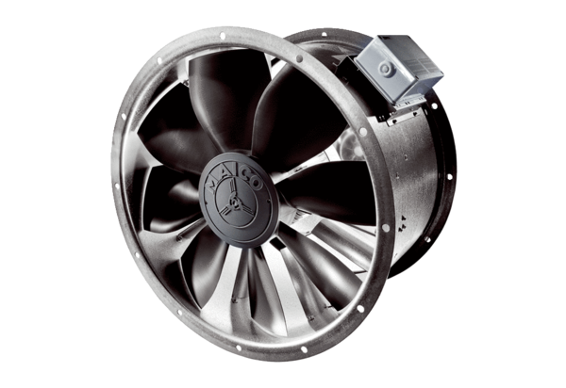Axial duct fan DZL 40/42 BPacking unit: 1 pieceRange: C
Article number: 0086.0098Manufacturer: MAICO

