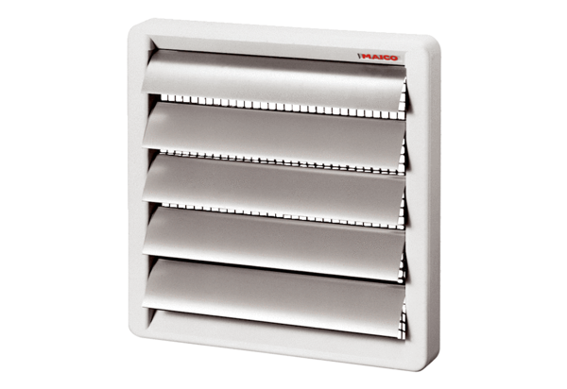Shutter AS 30Packing unit: 1 pieceRange: C
Article number: 0151.0332Manufacturer: MAICO

