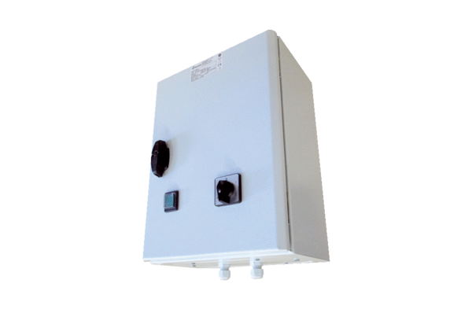5-step transformer TR 6,6-2Packing unit: 1 pieceRange: C
Article number: 0157.0150Manufacturer: MAICO

