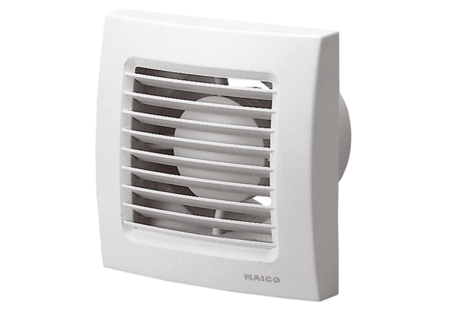Small room fan ECA 150 FPacking unit: 1 pieceRange: A
Article number: 0084.0014Manufacturer: MAICO

