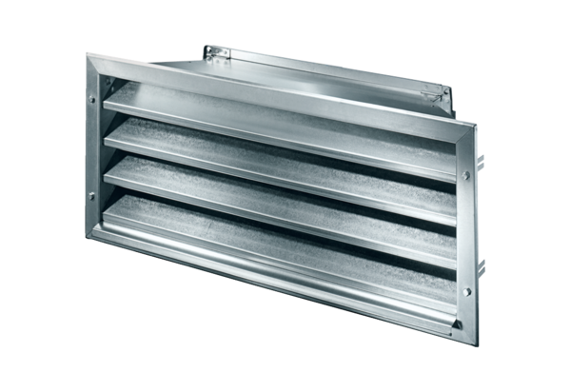External grille LZP-R 56Packing unit: 1 pieceRange: D
Article number: 0151.0387Manufacturer: MAICO

