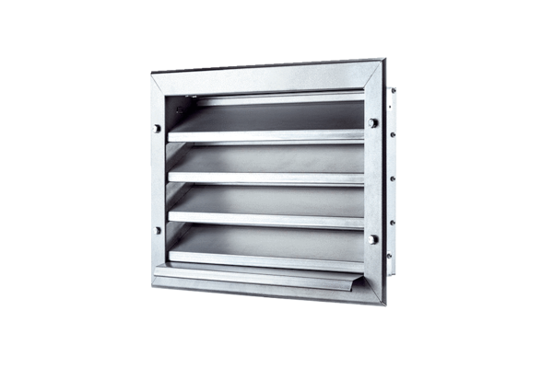External grille LZP 28Packing unit: 1 pieceRange: D
Article number: 0151.0257Manufacturer: MAICO

