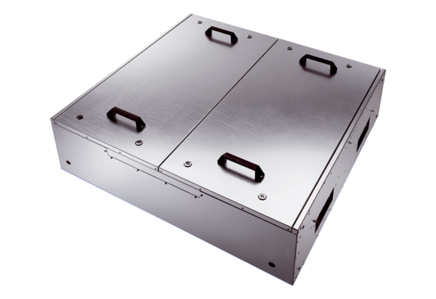Sound-insulated Flatbox for supply air with two air filters KFR 6030-FPacking unit: 1 pieceRange: K
Article number: 0080.0880Manufacturer: MAICO

