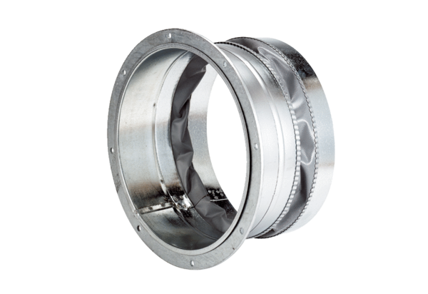Flexible coupling ELA 22Packing unit: 1 pieceRange: C
Article number: 0092.0282Manufacturer: MAICO

