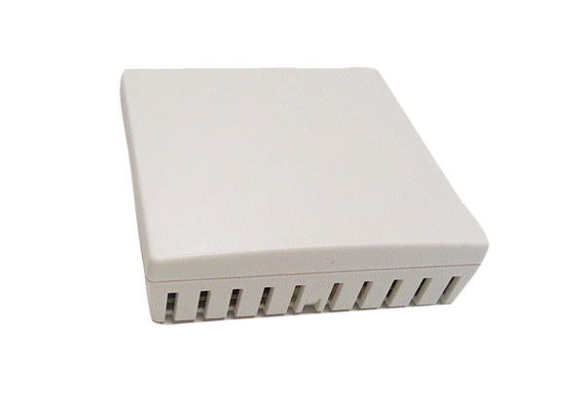Air quality controller Trio VOC IPacking unit: 1 pieceRange: K
Article number: 0157.1483Manufacturer: MAICO

