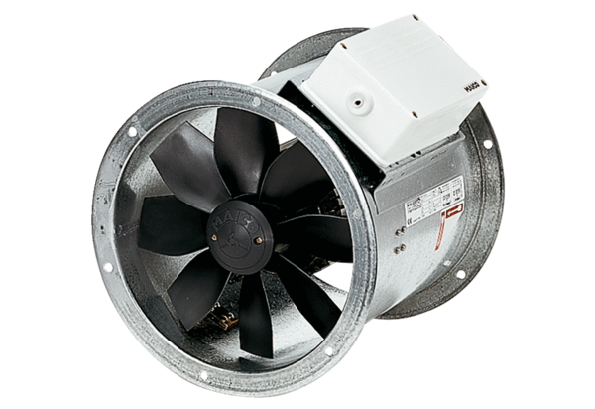Axial duct fan DZR 25/2 BPacking unit: 1 pieceRange: C
Article number: 0086.0022Manufacturer: MAICO

