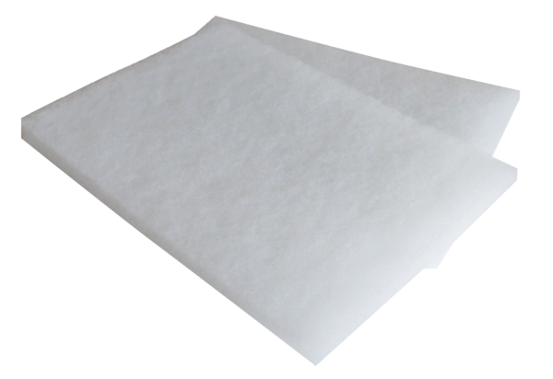Air filter, replacement WSG 600Packing unit: 2 piecesRange: K
Article number: 0093.0886Manufacturer: MAICO

