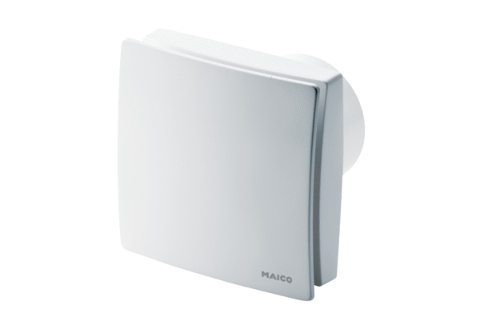Small room fan ECA 150 ipro KVZCPacking unit: 1 pieceRange: A
Article number: 0084.0092Manufacturer: MAICO

