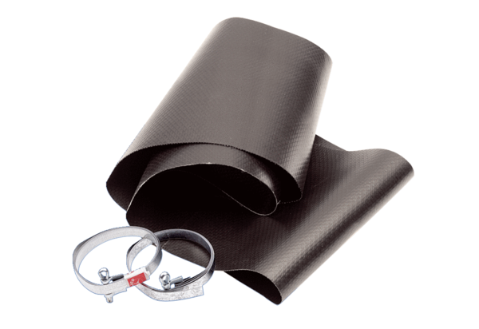Flexible cuff EL 56Packing unit: 1 pieceRange: C
Article number: 0092.0150Manufacturer: MAICO

