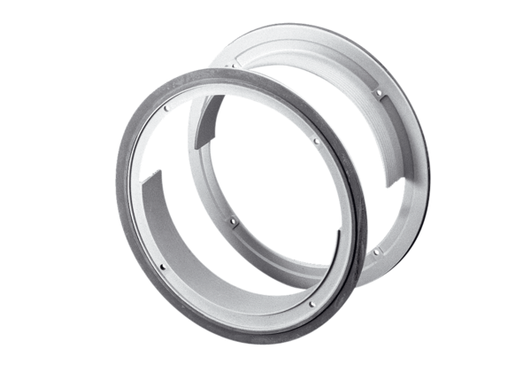Accessories for composite window ZD 31Packing unit: 1 pieceRange: C
Article number: 0093.0916Manufacturer: MAICO

